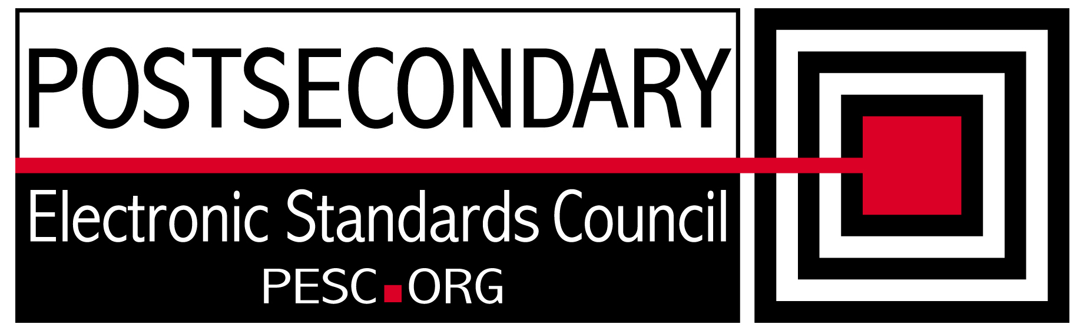

Standards Forum for Education
Status Update Form

Workgroup/Board Group Name | Technical Advisory Board
General Summary of Status | Developing a plan to moving to the NIEM framework for XML Exchange Standards
Status Flag (Red/Yellow/Green) | Green
Report Data | 12/09/2011
Projected Completion Date | Standing PESC Board

Item | Responsible Resource | Status  (Report update status of Deliverable/Objective  since last report)
Planned Deliverables/Objectives
(Provide at least 3)
Component Architecture: Single file schema | Morris/TAB | Reviewed NIEM subset schema approach and determined it may be the mechanism to reduce schema size
NIEM Evaluation | TAB | David Webber stepped through the different NIEM schemas and how they work together
Language Support | Hamidi/ Margenau | On hold pending NIEM discussion. NIEM supports language designation metadata
XML R&R | Morris/Sue Lou (FSA) | Discussed approach to fixing R&R bugs with Wei Wu, the FSA Programmer. Determined that we would update with the latest core and sector schemas
Guideline for XML Architecture and Data Modeling revision | TAB | Had two PESC Board augmented meetings discussing PESCs plan to work with the USED on the NIEM initiative
Accomplishments/
Completions
Issues/Obstacles
Meetings/Calls Since Last Update | 4

Note: Chairs and/or leaders of workgroups, boards and committees under The Standards Forum for Education are required to provide updates during the Steering Committee’s monthly conference call meeting held the second Friday each month at 2:00pm EST. Call in information is: 866-352-3799 *7696363*. Forms must be completed and submitted prior to meeting time. Forms may also be posted on the PESC website as needed to provide the community at-large with a means to obtain updates for ongoing, but yet to-be-completed development efforts.

To add rows to table, click outside of the table, to the right on the row where you want to add another row . With cursor blinking, hit the enter key. A new row will be inserted.

